Student Name: Weight: 5%
Student ID: Marks: /26

Lab: Creating a Simple Webpage
In this lab, you’ll demonstrate HTML development concepts and best practices. This lab may be completed during a provided work period or outside of scheduled class time, as indicated by your instructor.

Instructions
- Working individually, re-create a web page that contains the content described below.
- Uploaded the following to Brightspace:
- A link to your github repository
- A link to your github pages site
  - A screenshot showing successful validation of your page from https://validator.w3.org/.
- Submit your lab by the due date listed in Brightspace. See the marking criteria below for details on how you will be assessed.

Page Content
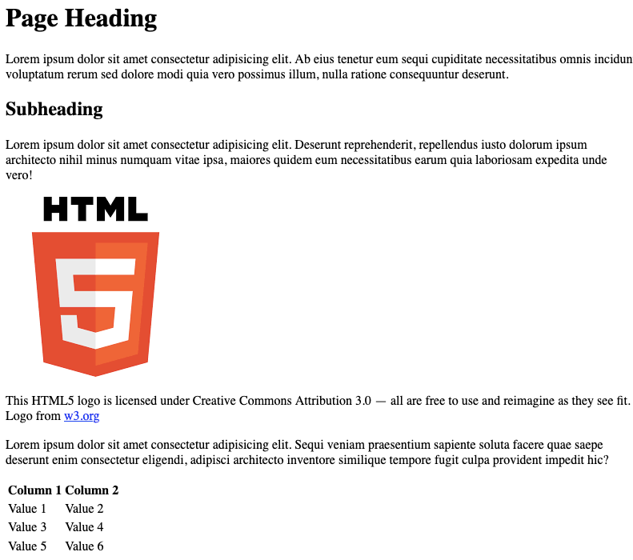
© 2022, Southern Alberta Institute of Technology
Notes:
- Generate placeholder text using your text editor or any lorem ipsum generator.
- The HTML logo is available from https://www.w3.org/html/logo.

Marking Criteria
 | 0 Marks | 1 Mark | 2 Marks | Marks
HTML Syntax | No HTML is submitted. | Code is visible on the page. | Page renders without visible errors. | /2
HTML Syntax | No HTML is submitted. | HTML has syntax errors. | HTML passes validation with no errors. | /2
Images | No image tag element is included. | The image does not appear. | Image renders on page. | /2
Accessibility | No images are included. | One or more images are missing alt-text. | All images have descriptive alt-text. | /2
Linking | No anchors are included. | Anchor does not work. | Anchor correctly links to another website. | /2
Tables | Table is not included. | Table does not render correctly. | Webpage includes a table. | /2
Tables | Table is not included. | Inappropriate table elements were used. | Table uses correct elements. | /2
Tables | Table is not included. | Table borders are visible | Table matches sample | /2
Heading | Use of heading tag missing | Heading tag not used correctly | Heading tags are used. | /2
Paragraph | Paragraph tags are not used | Only one paragraph tag is used in webpage | Paragraph tags are used. | /2
Reference | Image reference missing | Image reference included but not correct | Image reference is included | /2
Use of HTML | Used JavaScript to style page | Used CSS to style page | HTML only is used to create webpage. | /2
Output | Output doesn’t match with the given sample output | Output varies from the sample output | Output must match sample output. | /2
HTML Attributes | No HTML is submitted. | Obsolete HTML elements are included. | Appropriate HTML elements are used. | /2
Total |  |  |  | /28

